Annual General Meeting Minutes 2020/2021 Season
Held on Saturday May 1st 2021 Via Zoom Online Meeting

Meeting Opened: 11am.

Present: Members (Committee members, athletes & parents). See attached recording Participants on Zoom Below (54 Members, 1 Life Member (non-committee member) and 1 Ordinary Member making a total of 54 and two others). Quorum met.

Apologies noted: Michelle Baxter Hanna

Holger Philipp (President) welcomed members to the AGM and thanked all parents for their assistance over the season, and also thanked the Committee who worked hard not only behind the scenes, but also during meets as well.

Minutes of Previous AGM Meeting (season 2019/2020): Minutes from previous AGM held on Saturday 23rd May 2020 to be a true and accurate record of meeting.

Moved: Matt Warwick Seconded: Alisha Debono PASSED
Business arising from Previous AGM: NIL

President’s Report: As Tabled/Attached below.

Treasurer’s Report: As Tabled/attached below.
Moved: Dean McCaughan Seconded: Ross Thomson PASSED

Election of Auditor: CLA used Act Now Financial Consultants this financial year for the audit. Are members approving to use Act Now Financial Consultants again next season for audits? Members were asked if for unforeseen reasons, the audit could not be conducted by Act Now Financial Consultants, at the end of the CLA financial year, that the CLA executive team were to source another financial consulting firm to conduct the audit.

Voted and passed by majority vote. Voted
YES: 54members NO: 0 PASSED

Secretary Report: As Tabled/Attached Below.

Head Coaches Report: As Tabled/Attached Below.

Registrar’s Report: As Tabled/Attached Below.

Election of Committee for the incoming season:
Nominations received PRIOR to the AGM:
- President: Holger Phillip
Moved: Jo Sahabdeen Seconded: Nina O’Dea PASSED

- Secretary: Jo Sahabdeen
Moved: Alisha Debono Seconded: Kylie Moxon PASSED
- Treasurer: Gail Clappers
Moved: Connie Meier Seconded: John Frenken PASSED

- Registrar: Ross Thomson
Moved: Kylie Moxon Seconded: Lisa Black PASSED

- Vice President: Dean McCaughan
Moved: Gail Clappers Seconded: Michelle Frenken PASSED

- Head Coach: Kelly Carvill
Moved: Kylie Moxon Seconded: Lisa Black PASSED

- Grants and Sponsorship Chloe Brennan
Moved: Dean McCaughan Seconded: Archana Sharma. PASSED

- Assistant Secretary | Alisha Debono
- Assistant Treasurer | Megan Crowley
- Assistant Registrar | Bronwyn Philipp
- Assistant Registrar | Nicole van Brakel
- Assistant Registrar | Nina O’Dea
- Chief Referee | Matt Warwick
- Announcer | Michael Gorgieveski
- Program Manager | Michael Gorgieveski
- Logistics Manager | Peter Stonehouse
- Canteen Manager | Bernadette O’Neill
- Cross Country | Scott Culpin
- Assistant Coaches | Lisa Black
- Assistant Coaches | Michelle Frenken
- Assistant Coaches | Peiter Greiling
- Assistant Coaches | Angelos Konstas
- Assistant Coaches | Brianna Briet
- Assistant Coaches | David Kohl
- Grounds & Equipment | Brendon Crowley
- Assistant Grounds & Equipment | Paul Freestone
- On Track Co-Ordinator | Holger Philipp
- Photographer | Connie Meier
- Records & Results | Annette Neilson
- Assistant Records & Results | Sarah Clark
- Regional & State Manager | Paul Freestone
- Assistant Regional & State | Andrew Pryn
- Special Events/ Fundraising | Katrina Bocor
- Special Events/ Fundraising | Debbie Scott
- Jnr. Boys Team Manager | Meagan Borg
- Snr. Boys Team Manager | Meagan Borg
- Jnr. Girls Team Manager | Yewande Adelaja
- Snr. Girls Team Manager | Yewande Adelaga
- Multi Class Team Manager | Kara James
- Social Media & Website | Andrew Pryn
- Child Protection Officer (CPO) | Anthony Lakshan Rodrigo
- Liaison Officer | Jo Sahabdeen
- Liaison Officer | Lisa Black

Moved: Alisha Debono Seconded: Connie Meier PASSED

Nominations received AT the AGM:
- Merchandise Supervisor Vicky Delgos
- Merchandise Supervisor Kyle Moxon
- Special Events/ Fundraising Team VACANT
- Child Protection Officer Archana Sharma

Moved: Alisha Debono Seconded: Jo Sahabdeen PASSED

Comments/Questions from the Members: NIL Meeting Closed: 11.49 am

Reports attached:

Recorded Participants on Zoom:

Alisha debono
Michelle Frenkan
Mark Frenken
Kylie Moxon
Michelle Maling
Lisa Black
Kerrie McCaughan
Archana Sharma
Kelly Carvill
David Kohl
Bec parker
Chloe Brannan
Michael Gorgievski
John Brannan
sonali chopade
Connie Meier
Yvette-Derrick
Sarfo-Sarpong
Gregory Konstas
Jon Black
Caz and John Frenken
Paul Freestone
Yewande Adelaja
Vicky Delgos
Nina's O’Dea Family (2)
Holger Philipp
Gail Clappers
Jo Sahabdeen Family (2)
Ross Thompson
Andrew Pryn
Pieter Greyling
Mark Sullivan Family (2)
Dean McCaughan
Matt Warwick
Annette Neilson
Meg & Brendon Crowley
Adam Bocor
Tim Kallista
Van Brakle Family (2)
Kara James
Roohveen
Bhutani Family
Diamond Beazley Family
Tilley Family
Aliva Family
Rozareo Family
Wijeseinghe Family
Hamm Family
Roshi Family

Dianne & Andrew Pryn (1 Life Member 1 Ordinary Member – Both not voting)

President Report- Holger Phillip

Hello everyone and welcome to the Cranbourne Little Athletics Club AGM. Thank you to all those who are attending both here and online. Feedback I received last year was that my update was too long, so I promise to keep it much shorter this year. It didn’t look like we were going to get a season at one stage last year, but here we are at another AGM and Presentation. It definitely wasn’t a normal season, and whilst we couldn’t do everything we wanted to, we did the one most important thing we are here to do – have an event each and every week for the athletes to compete in.
That sounds so simple, but with the almost weekly Government changes the ambiguity and then the rush to get things organised quickly it really is an absolutely amazing effort and I think we should all be very very proud of the season we put together! I just would like to stop for a minute and thank everyone those on the committee as well as those that aren’t who helped both on Saturdays to ensure the kids could do their events and those behind the scenes to keep the show going. Well done and thank you! Can I get a virtual clap? Little Athletics is run on volunteer help and I couldn’t be anymore direct in saying some events and even the canteen and BBQ were very close to not be happening if it wasn’t for the last-minute help. Thank you again and please keep that in mind for next season.
With all this craziness, the club overall is in great health – both on and off the track. We had records broken all over the place - on the tack, attendance records record number of PB’s and fantastic representation at both State and Nationals!
Financially we have survived and are stable and the Treasures report will highlight that. In the grants and Sponsorships space a few highlights include:
- $3000 cash into the club from sponsorship and an additional $2550 invested in other contributions. Total of $5550 from sponsors.
- Villawood have been a major supporter of ours over many years now.
- We had 10 major sponsors this season (increase from the 7 we had last season) and welcomed 6 new sponsors this season.
- We received $9278.12 from successful grant applications. Two big grants with Coles Grant and the DHHS Shade Grant. We have been able to purchase new expensive heavy-duty marquees with that funding.
- Total contributions 2020/2021 = $14,828.12 (That is an increase of $2453.40 from last season)
- So that’s over $27,000 for the club over the past two seasons.

Finally, I would like to thank everyone for making my experience at Cranbourne a really pleasant and enjoyable one.

Treasurer Report- Gail Clappers

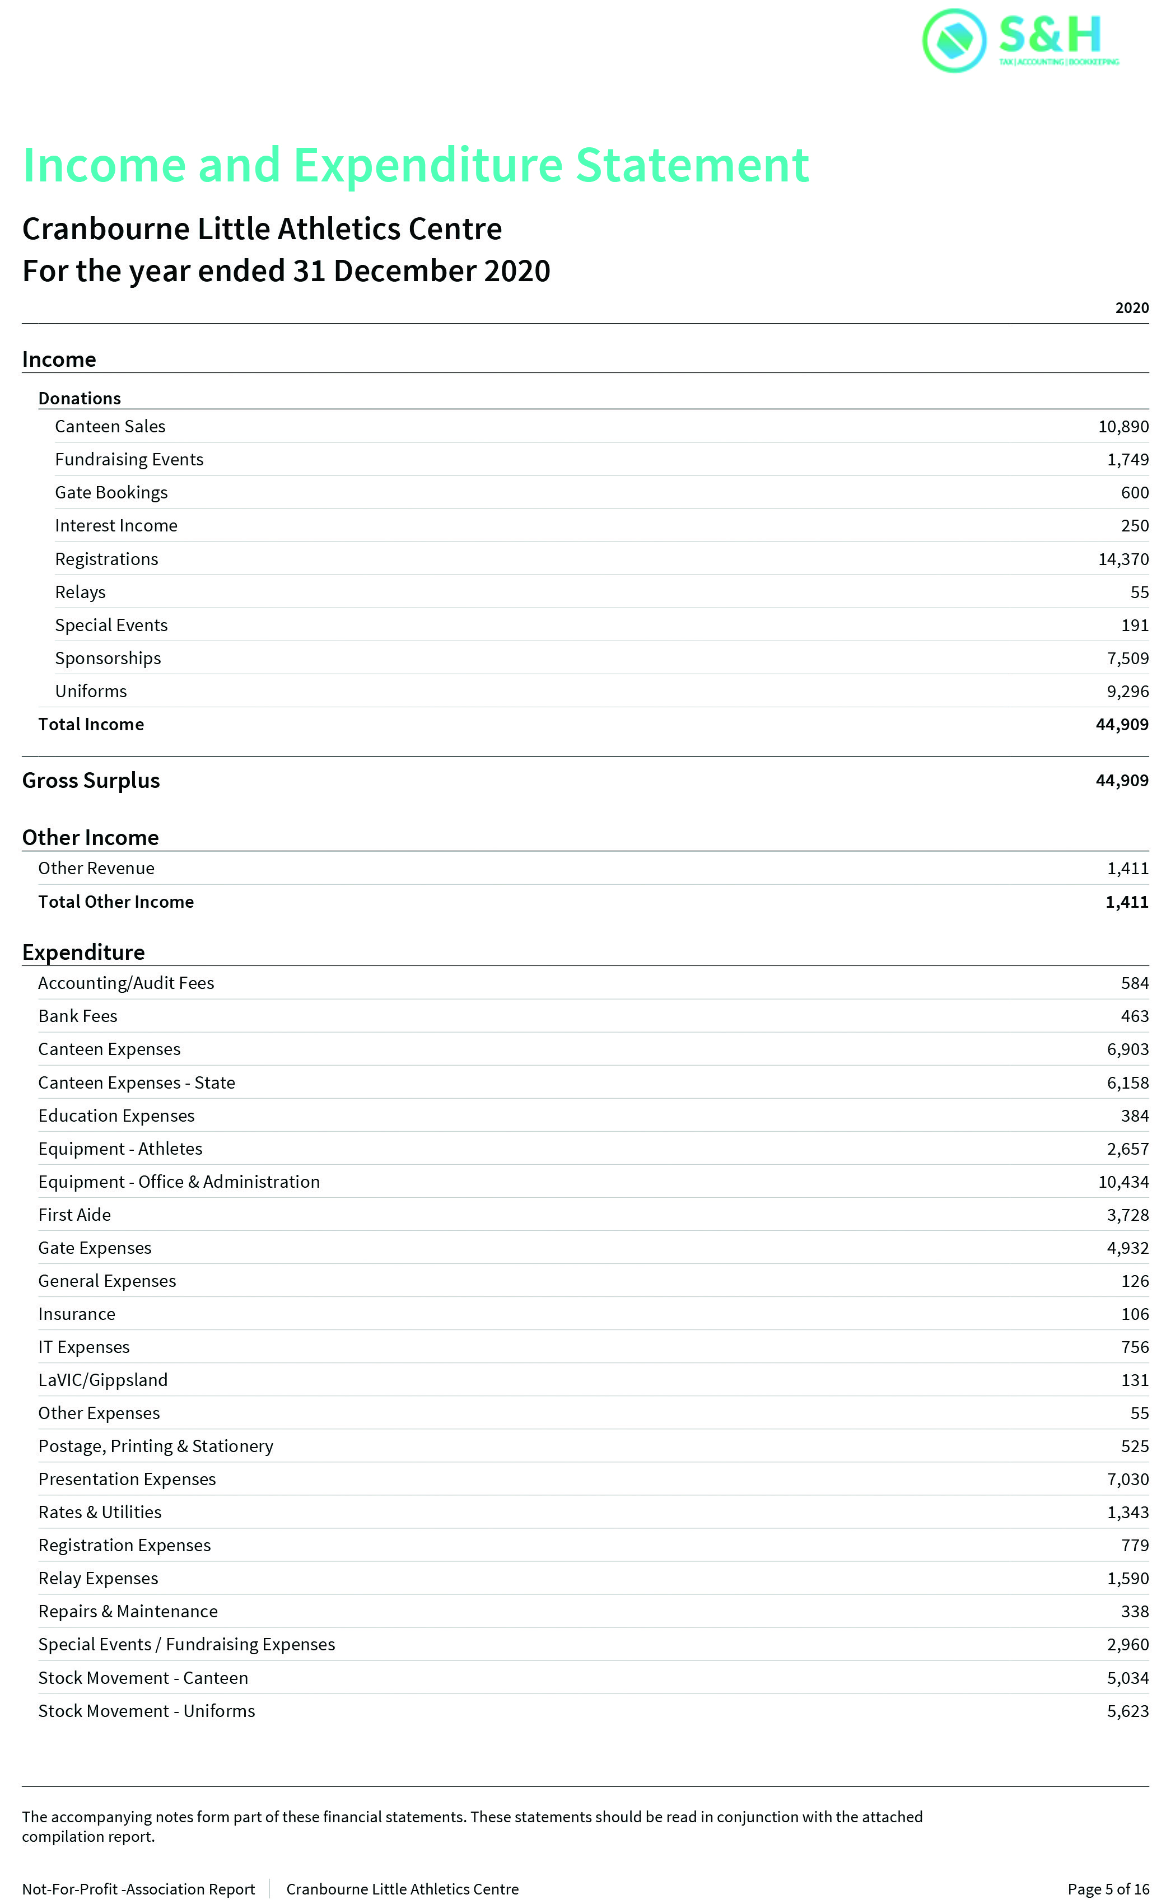
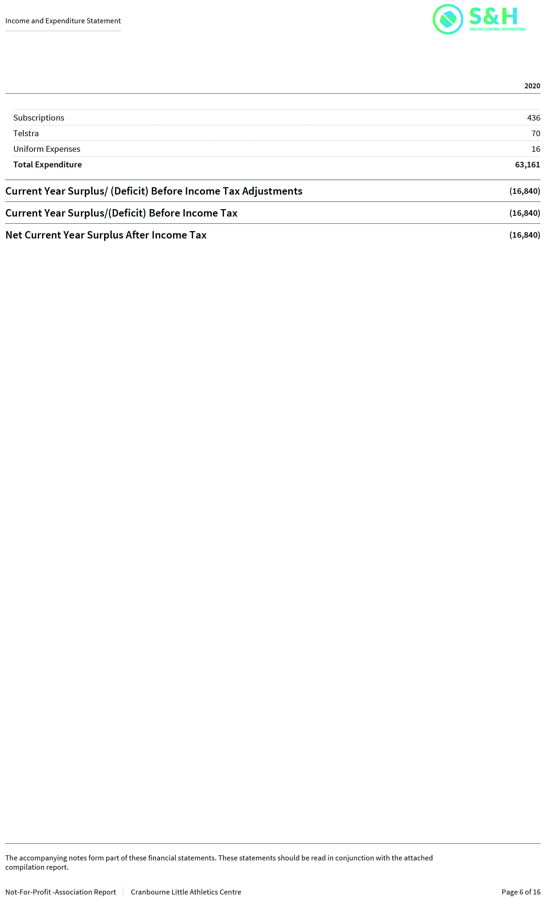
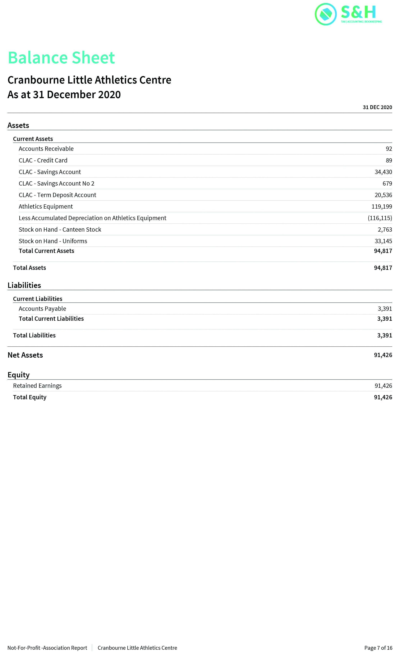
Secretary Report- Jo Sahabdeen

Hi all, I grabbed the baton from the past Secretary, with enthusiasm. What a season! It didn’t run to usual plan due to covid, but we got there, and I am thoroughly enjoying.
A big part of my role was meeting and greeting new and old members, talking to members on the phone and learning my way around.
I was very happy to be involved in getting the season up and running, at the last minute, I might add. I would like to thank the team on the Committee for support, each and everyone of you helped when I needed it, and all the members understanding, being patient, and the club got there in the end.
Everyone has been so great and it has been wonderful seeing all the smiling faces each week, enjoying Little Athletics and having fun.
Looking forward to the 21/22 Season.

Registrar Report- Ross Thompson
Season 20/21 has been very different in terms of registrar activity. The way we came out of covid lockdowns saw people trying out new sports all across summer, with huge amounts of trials and new sign ups all the way to the end of the season (we even had people trialling on the last day of competition). In a shortened season we came really close to equalling last years numbers, ending on a total of 306 active members. We’re still receiving sign up enquiries for the cross country season and very early enquires for next season! As our clubrooms were being used by the covid testing team we were forced to bring the registrar setup out onto the balcony, and aside from a few windy days this was a huge success as it meant the registrar team was able to take on some extra duties including medal & certificate presentations and running our awesome new engraving machine. Between enquires, sign ups, trials, presentations and engravings we really didn’t have a quiet day for the whole season, and it truly did take a team effort to deliver.
I want to thank my wonderful team for their dedication to the club. They sacrificed every Saturday morning missing out on seeing their own kids compete to ensure every one of our athletes had the best possible experience. They helped kids who were upset, they helped parents who were stressed, and they made sure every single kid who got presented a medal felt like they’d just won gold at the Olympics. So to Nicole, Bronwyn, Nina and Lisa I am so grateful to have worked with you this season, you turned “Registrar” into “Team” (an amazing one at that) and I am proud to have been a part of it!
Head Coach Rerport- Matt Warwick

It’s great see everyone still show up every week with all the COVID hoops we all had to jump through to make this season happen. Big thanks to all the coaches that turned up every week to training and comp days to help our athletes get the best out of them. I’ve been apart of this club for many years, this year has been toughest yet, it’s a credit to everyone and how we got though together. I believe this has made our club stronger then ever.
I’ve love being a part of this great club CLA.
Watching our kids and how they grow into more than athletes. All the friendships, PBs, records and how well we did at state level as a team, I couldn’t be more proud of all our athletes.
The future of our club is in great shape,
Thanks
See you on the track.

